**B2B Travel Company**

Week – 6

In this week, I’ve completed so many works as such that which are illustrated below in the following points:

1. First, I’ve created a **Explore Services** and **Get Started** button in the front page such that the user can directly go and checkout the services.  
   The **Explore Services** button will take the user to the **Services** page and the **Get Started** button will move the page slowly downwards.

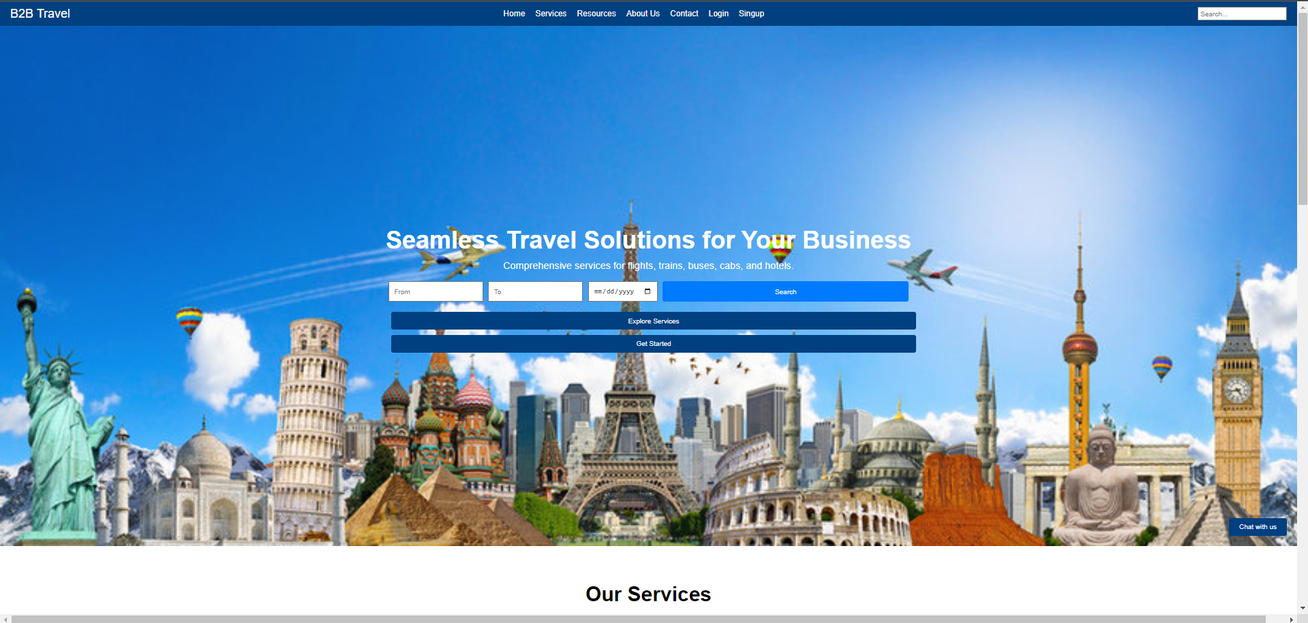

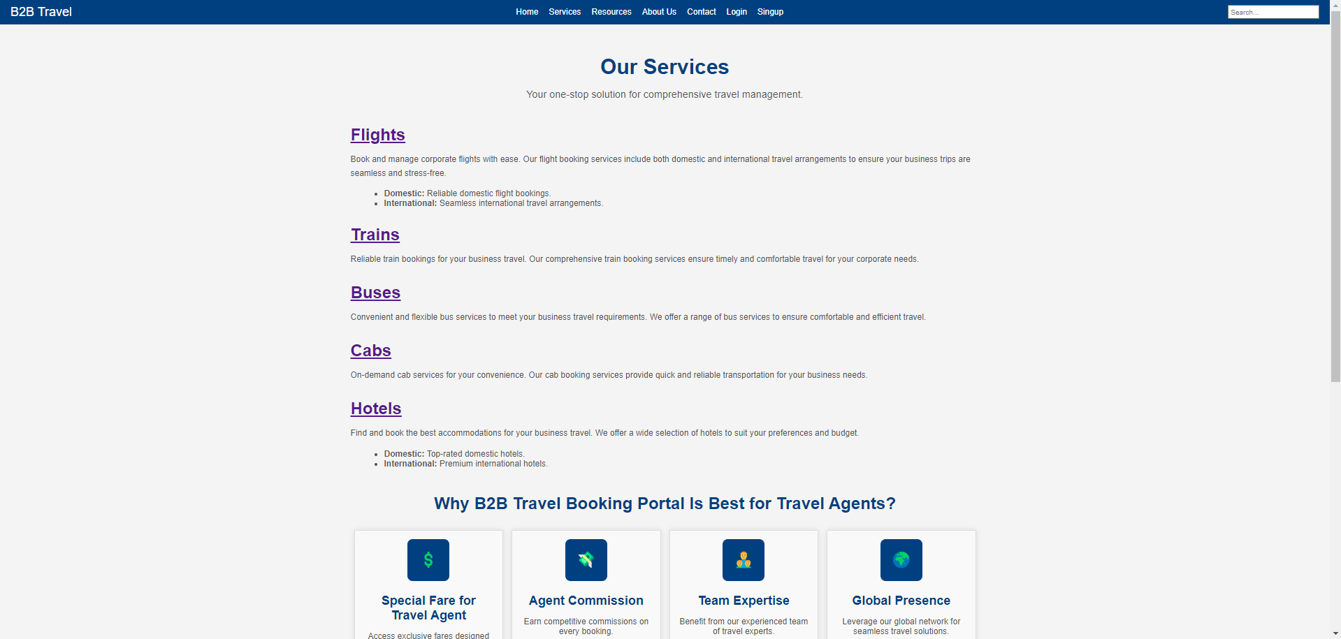

1. I’ve successfully created the working **Signup** page on which when you will enter your details the data is saved in firebase and you can login to the account.

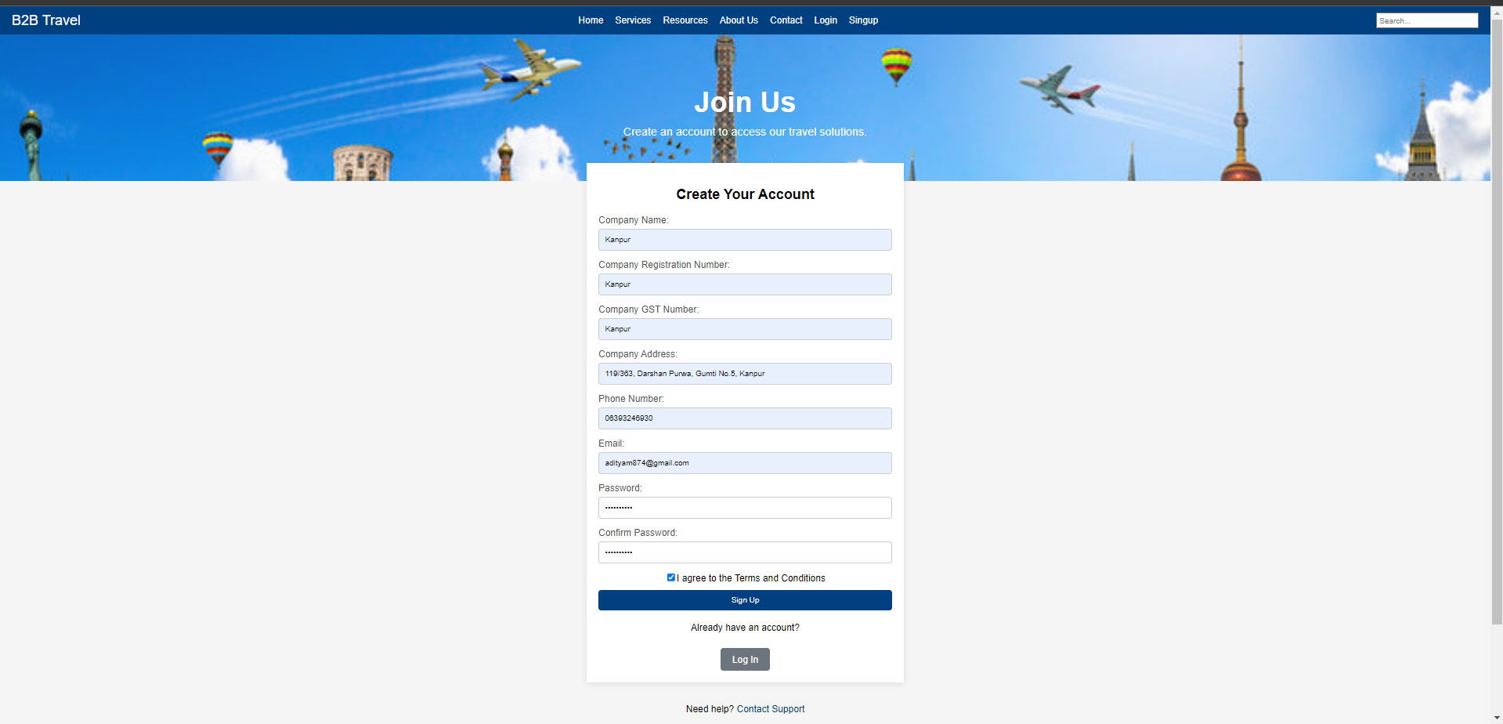

1. After creating successfully signup page, I’ve created working **Login** page in which when you will click on the login button it will redirect you to the **Dashboard** page.

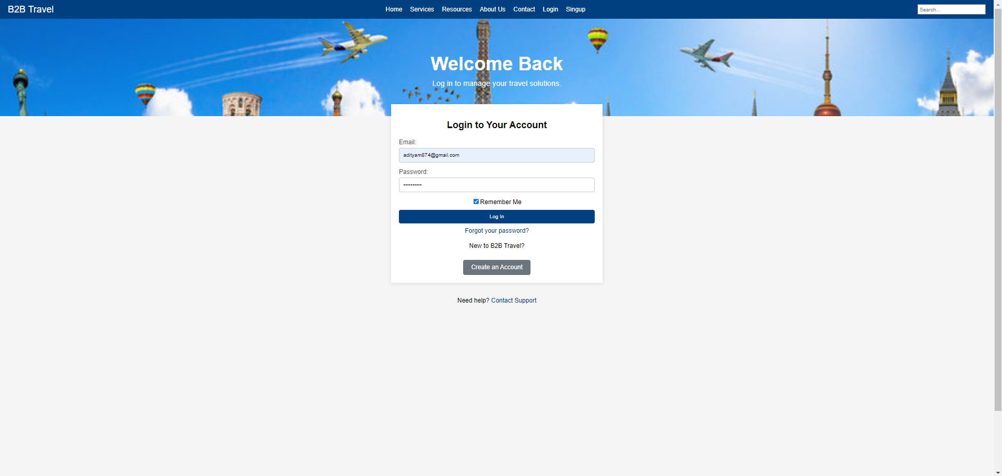

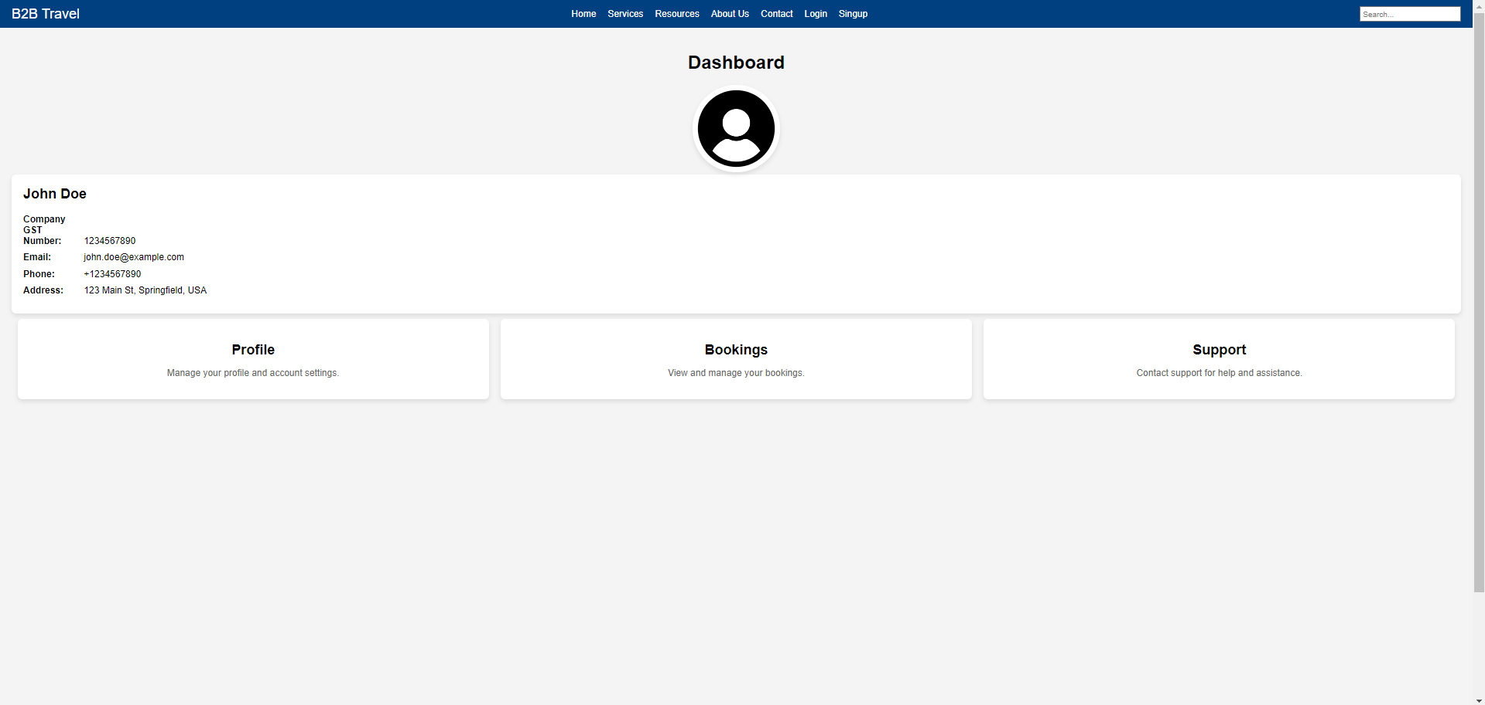

It’s taking time in building the website because I’m not able to find the correct web API which gives information about our services like flights, trains, etc. I got one or two API but they are paid and some of them are giving error while integrating in the application.

So please, give me some time to explore some good API for our services.